Computer Vision HW10

姓名：周秉儒

學號：r07922166

Laplacian mask = [ [0 , 1, 0]

[1, -4, 1]

[0, 1, -4]]

Threshold = 20

Result = 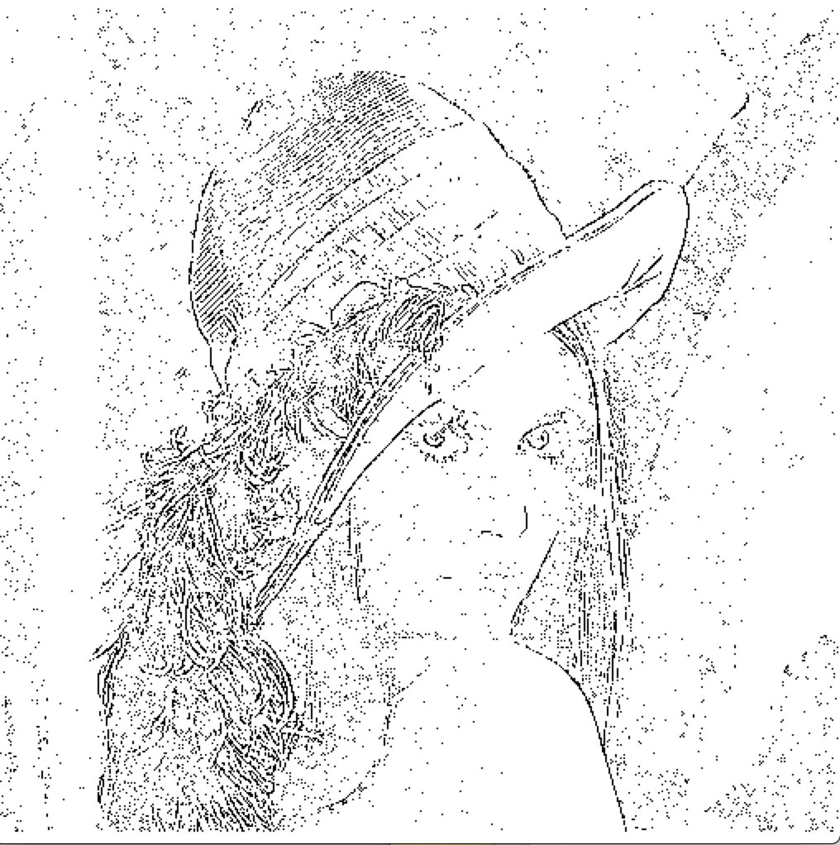

Laplacian mask



Threshold = 15

Result =

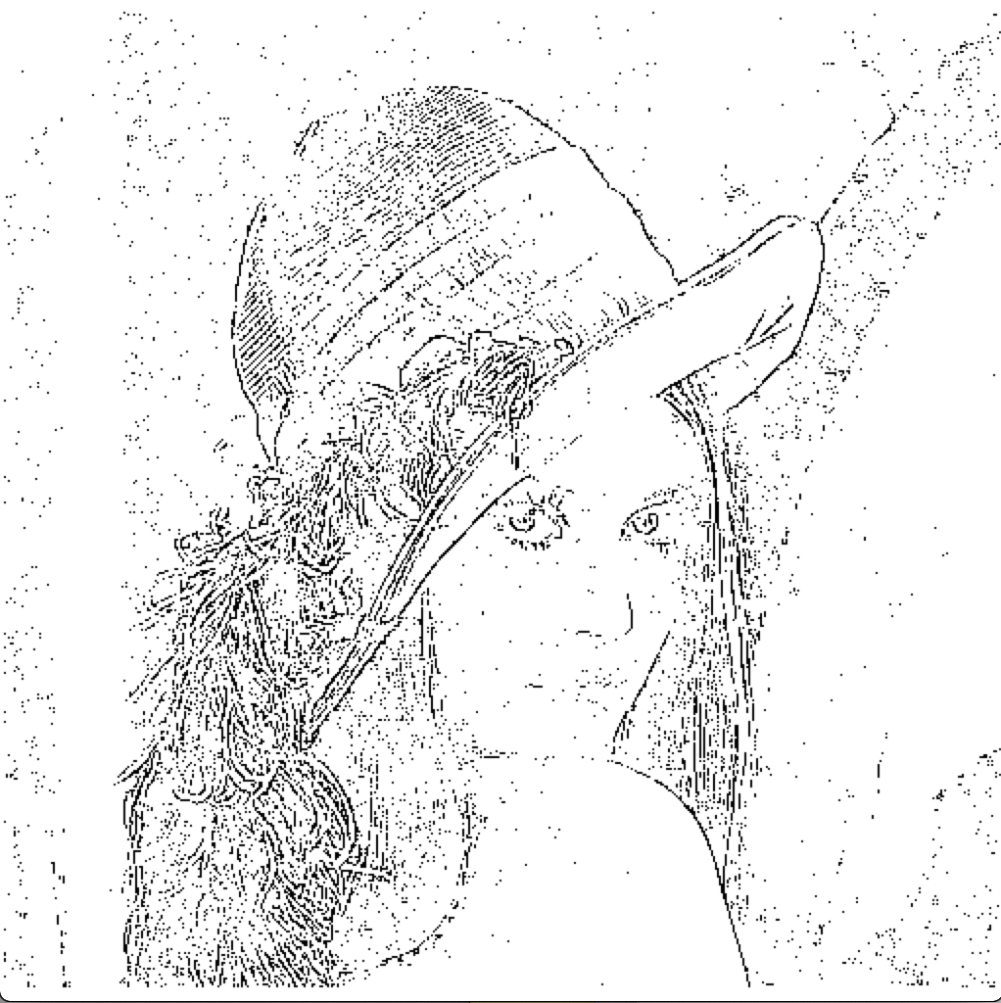

Laplacian minimum variance

Mask =



Threshold = 12

Result =

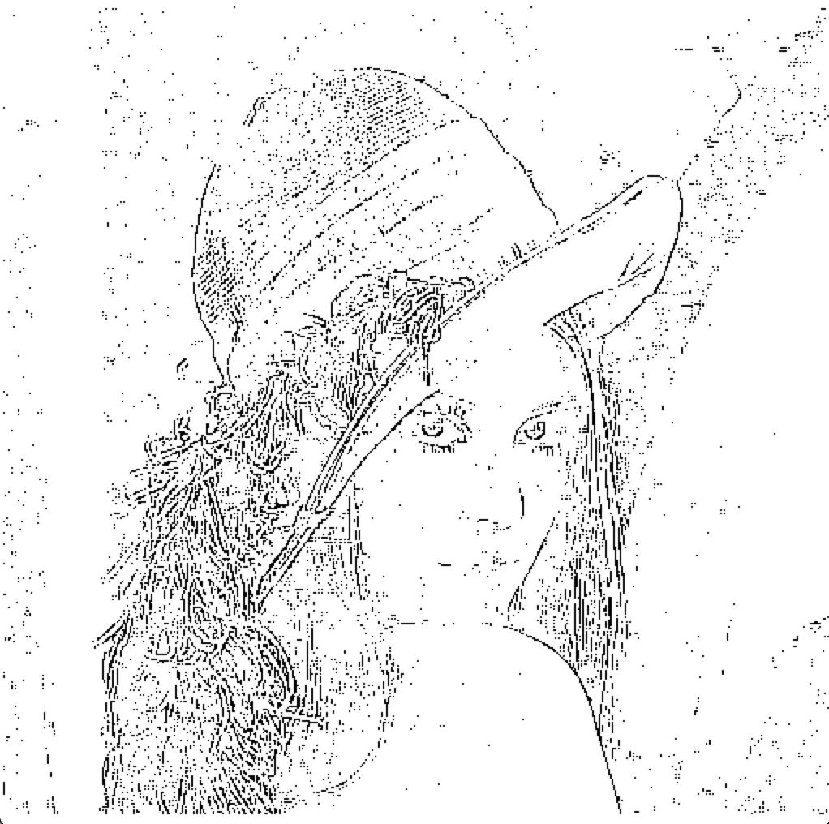

LoG

Mask =



Threshold = 1600

Result =

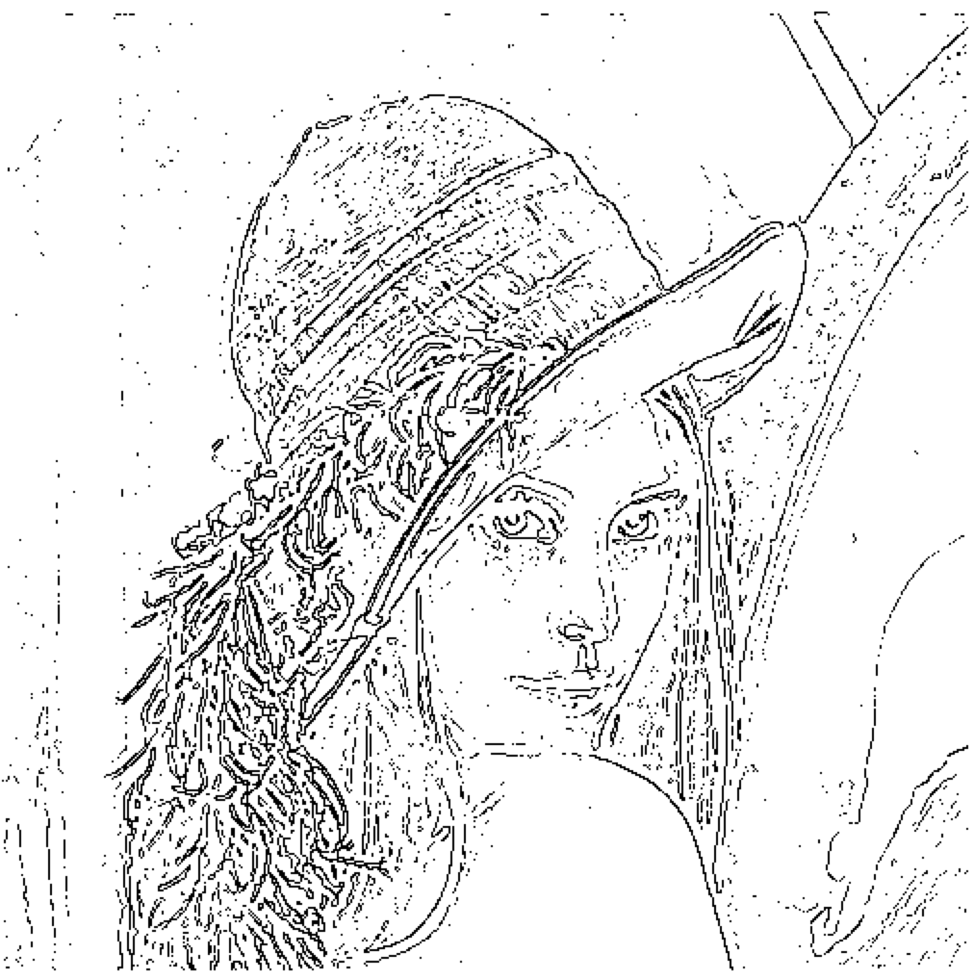

DoG

Threshold = 6

Result =

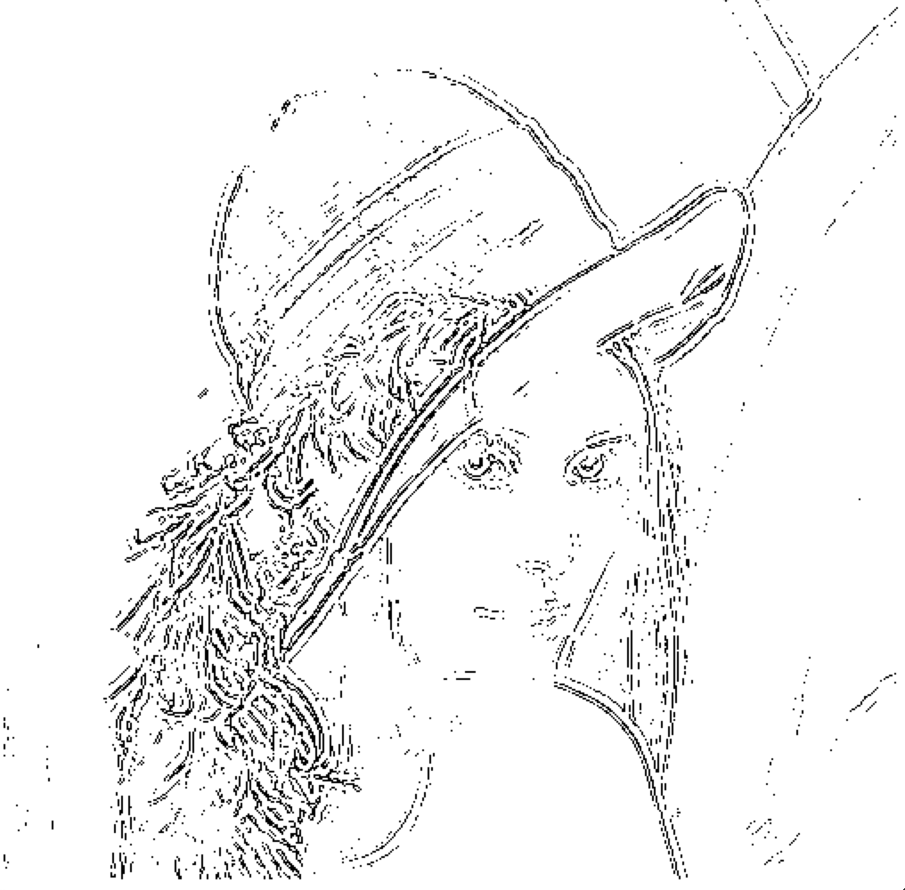

Mask 是用程式碼自己產生的，有附上程式碼

程式碼：



Function 產生DoG



這是抓出圖片中rowi，colj範圍為size(ex:3x3)的mareix

Laplacian :

